Error Message

When creating and updating any forms, this application will display an error message when a user does not enter input into fields with a red asterisk on their left.

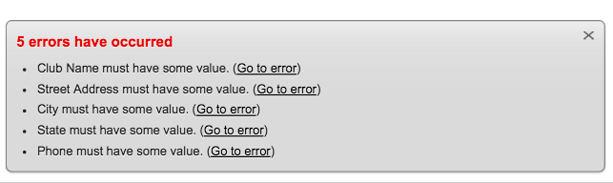

When creating and updating the Member Talent form, this application will display an error message when a user tries to enter an existing member that already has the talent they’re trying to give it. 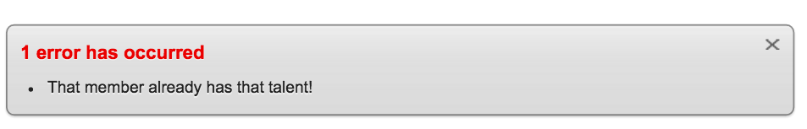

When creating and updating any forms, this application will display an error message when a user tries to enter an incorrect DATE format. 